My Blog Software Requirements

Goals

(what we trying to acheive)

1. Create a Blog to be able to share and stories and knowledge with other

User Stories

As a <User>, I want <Goal> so that <some reason>

TASK: Complete 3rd User Story for being able to add a new post

1. As a viewer, I want to be able see the list of blog post(s)
2. As a viewer, I want to be able to select specific blog post so that I can read the content
3. As a Admin, I want to be able to create a new post, so I can add more post when I want to

User Flow

TASK: Complete the 3rd User Flow

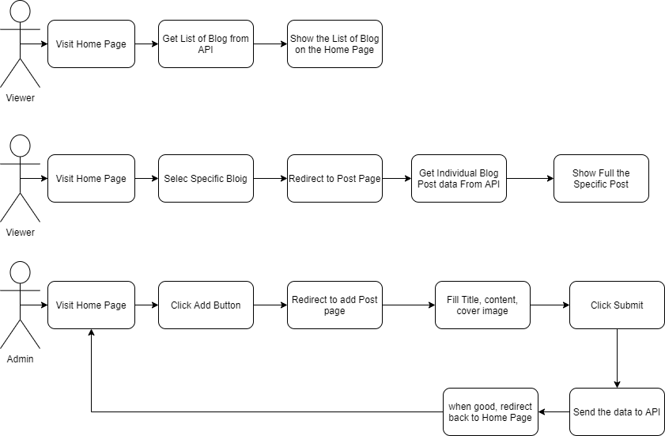

Business Requirements

TASK: Complete New Post Page Requirements

* Pages
* Home page
* Individual Blog Page
* Create new Blog page
* Home Page
* Display Admin brief intoduction
* Show list of post with title, dates, contens
* Limit the content text to a certain height to give brief information about the post
* Individual Blog page
* Show the cover picture
* Show the post content with title, dates, and the full contents
* Back button to return to homepage/previous page
* Create new Blog page
* Form to input new Post title, content, and cover image
* Submit button to send the data to API and post it to home page
* Store the added date automatically after submit button pressed
* Back button to return to previous page/home page

Technical Requirements

* Front End using JavaScript
* Back End using NodeJS
  + Rest API
* Database
  + JSON
* API Endpoints
* Get List of Blog Posts
* “api/post”
* Get Individual Blog
* “api/post/:post_id”
* Post Blog Post
* “api/post”